**NCV2 Robotic Fundamentals Module 5**

**Module 5:** **Programming**

**(RaspberryPi – Scratch development environment for GPIO programming, and Pythin using IDLE and MU)**

## 5.1 Basic concepts of GPIO programming

Content:

* Computer programming principles
* GPIO Programming

### 5.1.1 Define the term Programming

**DEFINITION**

Programming is the implementation of logic to facilitate specified computing operations and functionality. It occurs in one or more languages, which differ by application, domain and programming model.

Source code is another name for computer program instructions, and program coding is another name for computer programming. An application is constructed using the semantics and syntax of a programming language. Programming requires knowledge of application domains, algorithms, and programming languages. There are hundreds of programming languages, which can be used to write computer programs and following are a few of them:

* Java
* C, C++ , C#
* Python
* PHP
* Perl
* Ruby
* JavaScript
* Kotlin

Programming language logic differs by developer. At a high level, good code can be evaluated with factors such as:

* **Robustness**: Focuses on program continuation capability, regardless of errors or incorrect data
* **Reliability**: Focuses on correct design and algorithm implementation
* **Efficiency**: Focuses on memory, hardware or other properties used to optimize programs
* **Readability**: Proper documentation and indentation availability, which provides insight to other program developers or designers

### 5.1.2 Explain the term physical computing

Physical computing is the application of physical, embedded interactive systems with microcontrollers that can sense their environment and/or control outputs like lights, screens, and motors. It is creative and educational to put together a physical computer's hardware components and program it to perform the desired function. There are many established physical computing products on the market, including the BBC Microbit, Raspberry Pi, Arduino, and Circuit Playground. In this module, we are going to make use of the Raspberry Pi with Scratch and Python.

**eLink**

<https://www.youtube.com/embed/XYXLamqbl3k>

### 5.1.3 Describe the term electrical system in terms of inputs and outputs and basic signal processing

There are three fundamental components of electrical systems: resistors, capacitors, and inductors, which are correspondingly defined by resistance, capacitance, and inductance, which are generally deemed lumped parameters.

Electrical grids, which supply electricity to buildings and businesses over a wide area, are examples of power systems. Generators that produce electricity, transmission systems that move electricity from generating centres to load centres, and distribution systems that deliver electricity to surrounding residences and businesses make up the electrical grid. Additionally, smaller power systems can be found in residences, businesses, hospitals, and industries.

There are two main types of signals used in electronics: ***analogy*** and ***digital*** signals.

 Analog signals are time-varying and generally bound to a range (e.g., +12V to -12V), but within that range, there are infinite possibilities. An analogy signal is one that depends on the properties of a medium to convey its information, such as electricity moving through wires. Signals can be represented by voltage, current, or frequency variations. The analogy signal is often calculated in response to changes in sound, light, temperature, position, pressure, or other physical phenomena.  When plotted on a voltage vs. time graph, an analogy signal should produce a smooth and continuous curve as shown on Figure 5.1

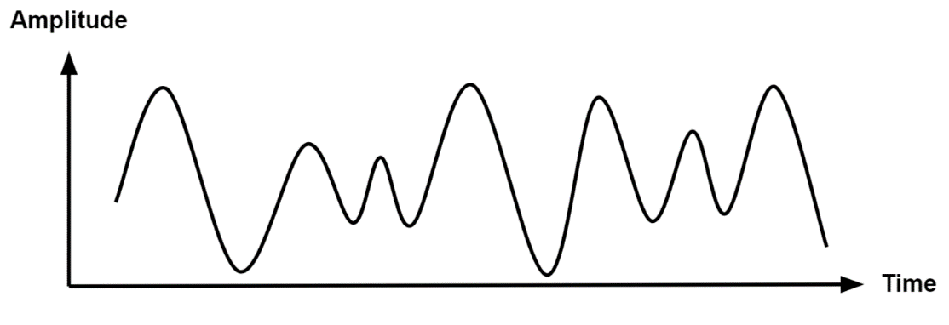

Figure 5. 1: Analogue signal

**Digital Signal**

Digital signals are signals that represent data as discrete values. Digital signals can only have one value at a time from a finite set of possible values. With digital signals, the physical quantity representing the information can be many things:

* Variable electric current or voltage
* Phase or polarization of an electromagnetic field
* Acoustic pressure
* The magnetization of a magnetic storage media

When plotted on a voltage vs. time graph, an analogy signal should produce a smooth and continuous curve as shown on Figure 5.2

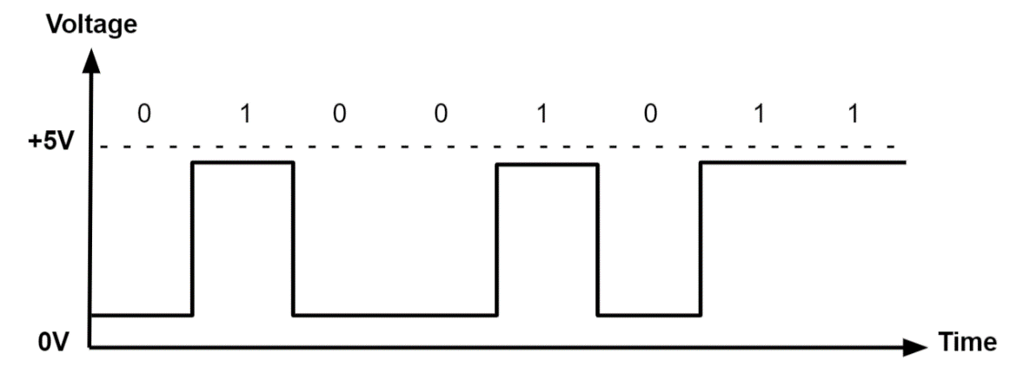

Figure 5. 2:Digital Signal

Table 5. 1: Comparison between Analog and Digital signals

|  |  |
| --- | --- |
| **Analog signals** | **Digital signals** |
| Analog signals are difficult to get analysed at first. | Digital signals are easy to analyse. |
| Analog signals are more accurate than digital signals. | Digital signals are less accurate. |
| Analog signals take time to be stored. It has infinite memory. | Digital signals can be easily stored. |
| To record an analog signal, the technique used, preserves the original signals. | In recording digital signal, the sample signals are taken and preserved. |
| There is a continuous representation of signals in analog signals. | There is a discontinuous representation of signals in digital signals. |
| Analog signals produce too much noise. | Digital signals do not produce noise. |
| Examples of analog signals are Human voice, Thermometer, Analog phones etc. | Examples of digital signals are Computers, Digital Phones, Digital pens, etc. |

### 5.1.4 Expand the term GPIO

GPIO stands for General-Purpose Input/Output. A general-purpose input/output (GPIO) is an uncommitted digital signal pin on an integrated circuit or electronic circuit board that may be used as an input or output, or both, and is controllable by software.

GPIOs have no predefined purpose and are unused by default. Integrated circuit (IC) GPIOs are implemented in a variety of ways. Some ICs provide GPIOs as a primary function whereas others include GPIOs as a convenient "accessory" to some other primary function.

**What Is GPIO Used For?**

The most common use for GPIO is to operate custom electronics. Whether you are building your robot arm or a Do It Yourself (DIY) weather station, a GPIO interface lets you customize signals so that they operate your equipment correctly.

### 5.1.5 Location of GPIO pins

An important feature of the Raspberry Pi is the row of GPIO pins located at the top edge of the single-board computer. These pins connect the Raspberry Pi to the outside world physically. At their most basic level, they can be thought of as switches, which you can turn on or off (input) or the Pi can turn on or off (output).

The GPIO pins allow the Raspberry Pi to control and monitor the outside world by being connected to electronic circuits. The Pi can control LEDs, turn them on or off, run motors, and many other things. It is also able to detect whether a switch has been pressed, the temperature, and the light. We refer to this as "physical computing."

GPIO pins are used to connect the Raspberry Pi to electronic components. To interact with different physical components, Python has two libraries known as RPi.GPIO and gpiozero. By invoking these libraries, you can take control of the GPIO system and make it do your bidding.

### 5.1.7 **Basic commands to the various GPIO pins**

To have the Raspberry Pi communicate with the outside world requires a programming language, and the most common one is Python. We are also going to use Scratch as it allows us to learn development concepts easily.

**Scratch**

Scratch is an easy-to-use block-based visual programming software that comes preinstalled on a Raspberry Pi4. With Scratch on this Raspberry Pi, you can create animations, games, and more using a straightforward drag-and-drop interface. Programming with Scratch is a great way to get students interested in computing and get them started with programming. When running our Scratch program on a Raspberry Pi, we can make use of the "GPIO" pins to interface with the outside world.

**Starting Scratch**

Once Scratch 3 is installed on the Pi, go ahead and open up Scratch 3 by clicking the Raspberry Pi icon on the top left of the desktop, then Programming>Scratch3

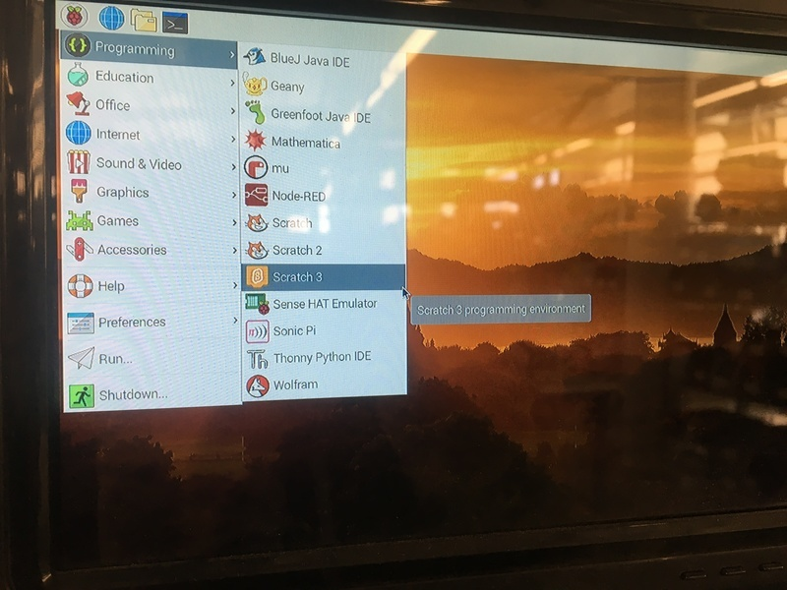

Figure 5. 3:Starting Scratch on Raspberry Pi

**Add the Raspberry Pi GPIO extension**

* Click the blue icon at the bottom left of the application to open the extensions.
* Select the extension entitled "Raspberry Pi GPIO". Now we have access to some awesome GPIO functionality.

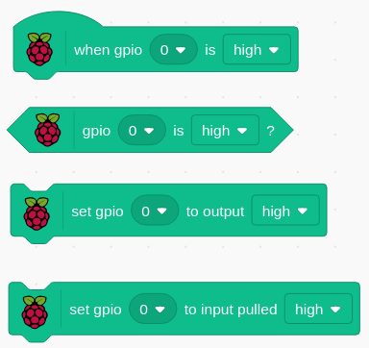

Figure 5. 4: Four common blocks of GPIO on Raspberry Pi

The GPIO extension gives you the flexibility to connect and control a whole host of electronic devices.

**Python**

Python is an interpreted, high-level, general-purpose programming language that has been around since 1991. It is currently one of the programming languages with the quickest growth. The "Pi" in Raspberry Pi standards stands for "Python Interpreter," indicating that this is the platform's suggested language.

Being an interpreted language, Python allows you to type in commands and run them interactively without needing to compile the program. They undergo run-time compilation into an intermediate bytecode, which a virtual machine then runs.

Every Raspberry Pi installation comes with an Integrated Development and Learning Environment, which you’ll see reduced to IDLE. There are several examples of IDE’s which come preinstalled on Raspberry Pi such as Mu, Thorny and IDLE. As for advanced IDEs such as Pycharm or Jupiter, you have to install them if you want to use them. IDEs are a group of programs that make it easier to write and debug code. Although there are several IDEs available, Python IDLE is basic, making it the ideal tool for a beginner programmer.

The interactive interpreter, sometimes known as a shell, is the finest place to explore with Python code. Essentially, the shell is a Read-Eval-Print Loop (REPL). It reads a statement in Python, evaluates the outcome, then prints the outcome on the screen. The following statement is read after a looping backwards.

Figure 5.6 illustrates Python IDLE code that adds two numbers and displays the results on the shell.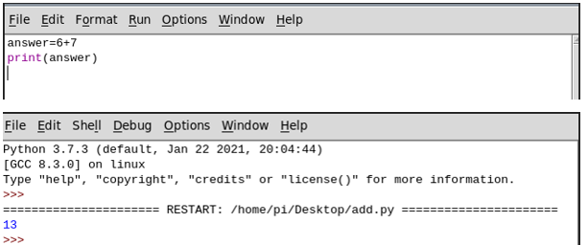

Figure 5. 5: Python IDLE screen

You have many different options for writing Python on Raspberry Pi. In this module, we will use the Mu editor to program our Raspberry Pi. There is not much of a difference with IDLE except that Mu has a better interface for both input and output.

### 5.1.6 Explain the purpose of the GPIO pins

There are 40 pins on the Raspberry Pi4 (26 pins on early models), and they provide various functions.

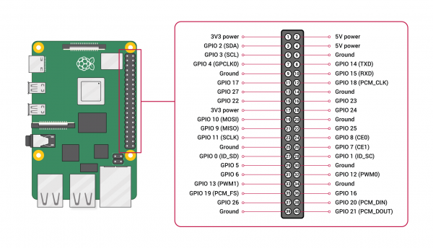

Figure 5. 6: GPIO pins on Raspberry Pi

GPIO interfaces are usually used in conjunction with a "breadboard". A breadboard is a rectangular plastic board with a bunch of tiny holes in it. These holes let you easily insert electronic components to prototype an electronic circuit. You can prototype circuits by adding, removing, or moving electronic components around. Many projects that involve devices like a Raspberry Pi allows you to assemble your device on a breadboard and then connect it to the GPIO pins using wires. GPIO-General Purpose Input/Output, aka "BCM" or "Broadcom". These are the big numbers, e.g., "GPIO 22". You will use these with RPi.GPIO and GPIO Zero. Physical or "Board" corresponds to the pin's physical location on the header. These are the small numbers next to the header, e.g. "Physical Pin 15". BCM: the number to be used in your Python or Scratch code to specify the GPIO to be used. BCM refers to the "Broadcom SOC channel" number, which is the numbering inside the chip that is used on the Raspberry Pi. These numbers changed between board versions.

Your microcontroller or computer must be able to understand the signals coming into the GPIO interface, as well as connect the GPIO pins to the appropriate connectors on your external circuit board. That means you need software, which you usually have to write! Python software is often used on Raspberry Pi systems to tell the GPIO controller what to send and what signals to listen for.

In some cases, the Raspberry Pi comes built into a keyboard. Such models do not require the purchase of a casing. The GPIO will be covered with a rubber enclosure to avoid dust and protect the pins from the outside world.

### **5.1.8 Explain how programming is used to send and receive signals from pins**

The Raspberry Pi has a 40-pin GPIO (General Purpose Input/Output) connection, which makes it very easy to connect to the outside world. To connect the GPIO to external sensors, you can:

* Connect the sensors directly to the GPIO pins using jumper wires
* Connect the GPIO pins to a ribbon cable, which in turn connects it to a breadboard. The Adafruit Pi T-Cobbler Plus - Breakout + Cable for Raspberry Pi A+/B+/Pi 2/Pi 4 is one such product. This option is ideal during the prototyping phase.

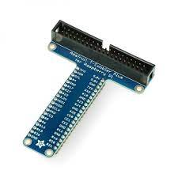

Figure 5. 7:The labels on the various pins on the Adafruit Pi T-Cobbler Plus

When using programming languages such as Python or Scratch, you will need to import libraries, which allows the computer to communicate with the external components attached to the computer through the GPIO. Among the easiest ways to control GPIO pins is by using the gpiozero library in Python. If you have written any Python code before, you will pick this up easy. Gpiozero is installed by default on Raspbian Desktop images. If you are using Raspbian Lite or a different operating system, you may need to install it.

### **5.1.9 Basic principles involved in programming**

No matter how they are programmed, computers work through input, processing, and output. Data or commands input into a computer must be processed before output can be viewed.

**Input**

Data entered or received by a computer is referred to as input. This could involve the user tapping a touchpad, clicking a mouse to pick an item on the screen, or pressing a key on a keyboard. While some inputs give the computer instructions on what to perform, others give it data to process. It is not necessary for humans to always initiate input. As an illustration, a computer may receive a message from another device or get data from a temperature sensor.

**Processing**

The process determines what the computer does with the input. The same input can be processed in different ways. A program contains the set of instructions that define the process.

**Outputs**

The output is how the computer presents the results of the process. Outputs can be returned to the user in many ways such as text on a screen, printed materials, or as sound from a speaker.

Here is a full example of input output and processing. We will use an example of a camera.

* Input: pressing the button on the top
* Process: it captures and stores a picture
* Output: the image is shown on the screen

**Discussion Points**

* Think about your day. How many times have you used a computer? Describe some of these times.
* Look at some of the examples you listed in the question above: – What was the input? – What was the process? – What was the output?

### **5.1.10 Programming languages suitable for GPIO programming**

Raspberry Pi supports several programming languages such as C, C++, Ruby, Perl, Scratch, Python, Java and PHP but, to access GPIO, all of them require additional libraries.

5.1.11 Start an applicable programming IDE from the OS

An integrated development environment (IDE) is software for building applications that combines common developer tools into a single graphical user interface (GUI). An IDE typically consists of:

* **Source code editor**- A text editor that can assist in writing software code with features such as syntax highlighting with visual cues
* **Local build automation-** Utilities that automate simple, repeatable tasks as part of creating a local build of the software for use by the developer,
* **Debugger-** A program for testing other programs that can graphically display the location of a bug in the original code.

**How to start Python on Raspberry Pi**

Python can be programmed using a variety of IDE’s on the Raspberry Pi such as Mu, IDLE and Thorny. For the purposes of this module, we are going to use Mu.

**How to start Mu to program in Python**

Open Mu by selecting it from the Programming menu.

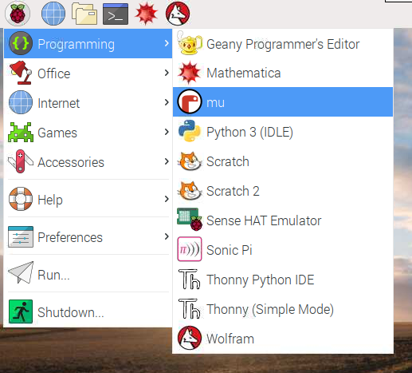

Figure 5. 8: Starting Mu

.

The interface looks like the one on Figure 5.8.

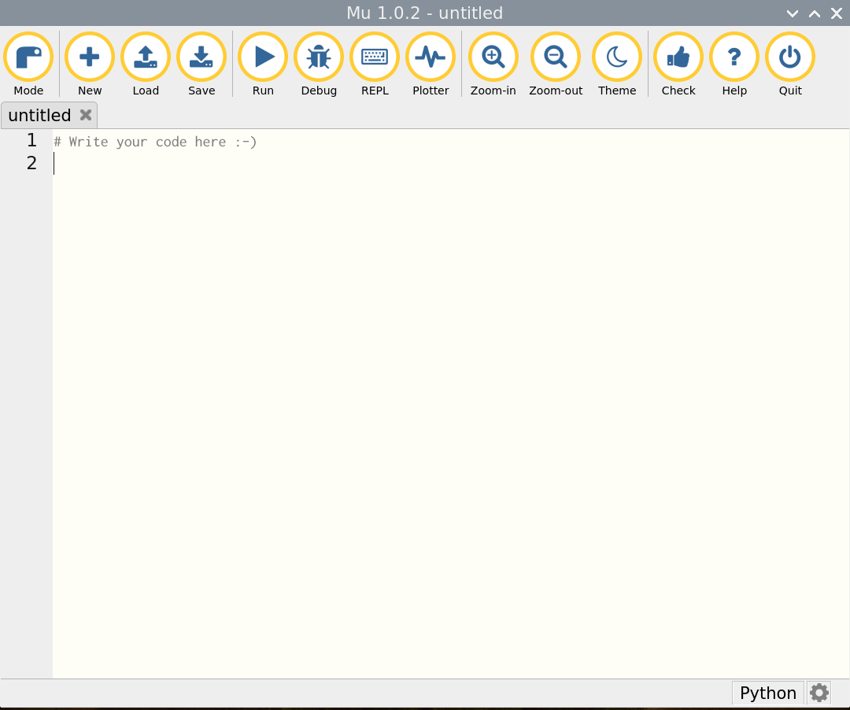

Figure 5. 9: Mu interface

### **5.1.12 Start or open an existing project (code project)**

Once Mu IDE is open, let us create a simple Hello World. The program will print the text inside the parenthesis. Please take note that Python text can be in double quotes or single quotes. As a programmer, you just need to be consistent. Mixing single and double quotations generates a syntax error. See sample code in Figure 5.9.

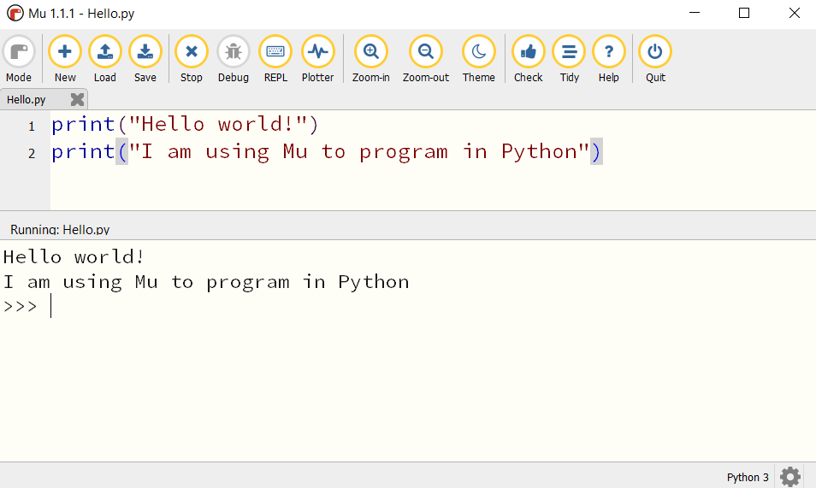

Figure 5. 10: Sample Python code

The keyword print allows whatever is inside the parenthesis to be printed as output.

### **5.1.13 Modify an existing code project based on new requirements**

We are going to modify the program in section 5.1.12 to allow the user to input two numbers and add the two. The program will print the output. Here is the modified code:

print("Hello world!")

#accepting user input and casting the value to integer

number1=int(input("Please enter value of first number: \t"))

number2=int(input("Please enter value of second number: \t"))

#processing the addition of number1 and number2 storing result in answer

answer=number1+number2

#displaying the output

print(number1, "+", number2 , "=" , answer)

Output

Hello world!

Please enter value of first number: 6

Please enter value of second number: 9

6 + 9 = 15

In the above example, we introduced variables. Variables are spaces in memory locations whose values can change. We use three variables in our program and these are number1, number2 and answer. We use an addition operator to do our addition. The "Run" button executes the current script. When this happens, the textual **input** and **output** of the program are displayed in a panel between the text editor and Mu’s footer. For further understanding, we refer you to the programming module.

### **5.1.14 Save an existing project**

To save an existing project, select the save button  and type in the file name. make sure to select the directory of choice.

### **5.1.15 Import applicable libraries or extensions**

We demonstrated how we can import Raspberry Pi extensions in Scratch (refer to section 5.1.7).

For Python, its easy to import libraries- we make use of the keyword *import <libraryname>*. In this section, we present four Raspberry Pi GPIO programming libraries: WiringPI, Pigpio, Gpiozero, RPI.GPIO. One of the libraries which we use so often in Python programming with Raspberry is the gpiozero. Officially endorsed by the Raspberry Foundation, gpiozero is a Python-only library that not only accesses the GPIO pins, but also provides direct hardware support for working with actuators and sensors. For connecting other devices, only SPI is supported — I2C was announced, but is not included yet GPIO Zero is installed by default in the Raspberry Pi OS desktop image, and the Raspberry Pi Desktop image for PC/Mac, both available from raspberrypi.org.

**Rpi.GPIO**

The RPI.GPIO library is another Python-only library. It provides basic interactions with the GPIO pins, but no implementation of any connection protocol yet.

**Pigpio**

The pigpio is an actively developed library with an impressive set of features: All GPIO pins of the Raspberry Pi can be read, written to, attached to interrupt handlers, and output PWM signals at the same time.

**Wiring Pi**

The WiringPi library is an often used, functional rich library that supports I2C and SPI connections. It is written in C and provides Python bindings. The library is unfortunately deprecated.

Here is an example of importing gpiozero library to power three LED lights which resemble traffic lights. We use three LEDs of different colours: Red Orange, and Green.

*#Program to turn ON/OFF the lights using Raspberry Pi***from** gpiozero **import** LED  
**from** time **import** sleep  
*#declaring the 3 variables -red, amber and green*red = LED(22)  
amber = LED(27)  
green = LED(17)  
*#Turning On/Off the lights using a sequence*red.on()  
sleep(1)  
amber.on()  
sleep(1)  
green.on()  
sleep(1)  
red.off()  
sleep(1)  
amber.off()  
sleep(1)  
green.off()

5.1.16 GPIO Inputs and outputs

GPIO pins consists of two buffers: input buffer and Output buffer. The other important part is an enable line with an inverter on the output buffer. If the enable line is set to 0 in software, the output buffer is set to enable which is a 1 and the pin is set to output. If the enable line is set to 1, input buffer gets activated and the pin gets configured into input mode. Generally, GPIO can be used in multiple ways.

1. [GPIO Output Mode](https://embetronicx.com/tutorials/tech_devices/understanding-the-microcontroller-gpio-gpio-working-explained/#GPIO_Output_Modes)
2. GPIO Input Mode
3. Analog Mode
4. Alternate function Mode

Figure 5.11 shows the simple implementation of a GPIO pin in a microcontroller.

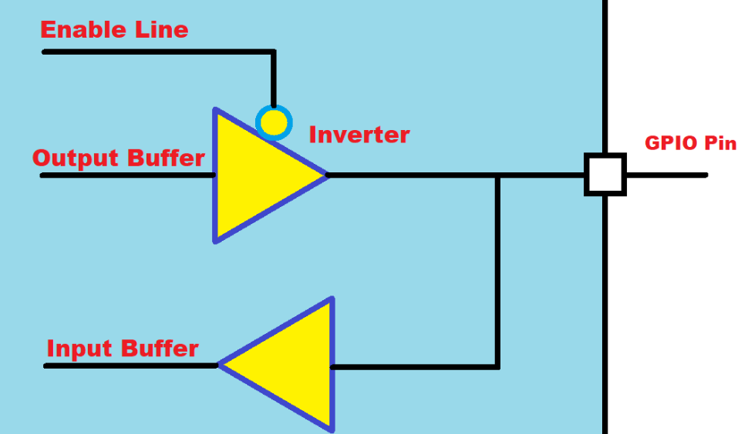

Figure 5. 11:Microcontroller for GPIO

Each GPIO pin consists of two buffers – Input buffer and Output buffer along with one enable line. When the enable line is **0**, the output buffer gets activated and the input buffer will be deactivated. When the enable line is **1**, then the output buffer gets deactivated, and the input buffer gets activated.

**GPIO Input Modes**

The GPIO is used to read the electrical signal in the pin when it is configured as an input. In general, GPIO inputs are primarily configured in one of three ways:

* High-impedance or Floating- keeping the pin floating by not connecting to either **HIGH (Vcc)** or **LOW (GND)** Voltage levels
* Pull-up - The internal pull-up resistor is connected to the pin. So, the state will be **HIGH** unless an external pull-down resistor is used
* Pull-down -The internal pull-down resistor is connected to the pin. So, the state will be Low unless an external pull-up resistor is used.

**GPIO Output Modes**

The GPIO is used to drive the electrical signal (high or low) to the pin when it is configured as an output. There are primarily two configuration options for GPIO outputs:

1. [Push-pull](https://embetronicx.com/tutorials/tech_devices/understanding-the-microcontroller-gpio-gpio-working-explained/#Push-pull)- This state is the default state of the GPIO output mode
2. [Open-drain](https://embetronicx.com/tutorials/tech_devices/understanding-the-microcontroller-gpio-gpio-working-explained/#Open-drain)

**Analog Mode**

You can configure the input as an analogy input. This mode connects the pin to an internal ADC (analogy-to-digital converter) and allows you to read a value that represents a given voltage in a pin.

When a GPIO is configured in analogy mode, the input pull-up/pull-down resistors are disconnected (floating).

### **5.1.17 Read and interpret a Pi GPIO Pin guide**

The easiest way to read and interpret the GPIO pin guide is first seeing the structure of the GPIO. By typing the command pinout from the raspberry Pi terminal, you will get the pin labels and also how your raspberry pi is built. The output will look as follows

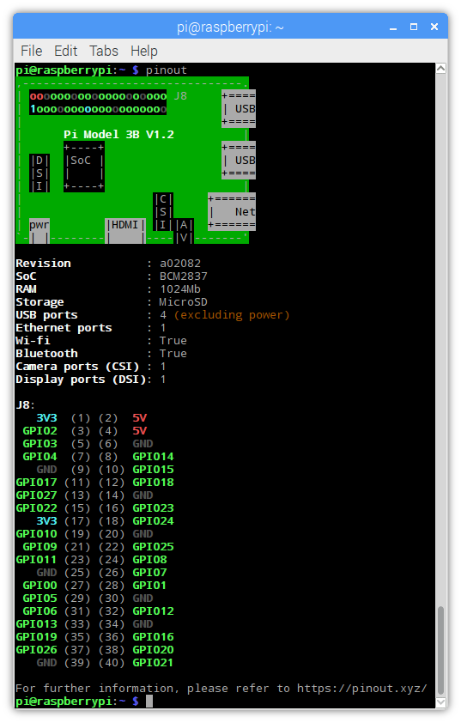

Figure 5. 12: GPIO Layout

### **5.1.18 Understanding 3V3, 5V, GND GPIO pins**

Using the Raspberry Pi as the example again, you will find a few types of pin:

* Pins that provide power at typical voltages such as 3.3V or 5V. This is to power connected devices that do not have their own power source, such as a simple LED.

3V3 (3.3 volts) - Anything connected to these pins will always get 3.3V of power.

5V (5volts) - Anything connected to these pins will always get 5V of power.

* Ground pins that do not output power, but are necessary to complete some circuits. GND - Zero volts, are used to complete a circuit.
* GPIO pins, which can be configured to send or receive electrical signals.
* Special purpose pins, which vary based on the specific GPIO in question.

### **5.1.19 Write basic I/O code to represent a solution to a problem**

In this section, we are going to demonstrate how to represent a solution to a given problem using Scratch and using Python. Given any problem, programmers start by making sure they understand the problem which needs to be solved. After, they identify a design tool which can represent how they will resolve the problem as part of planning phase. There are quite several design techniques which can be implemented. Some of them includes:

* IPO tables- The IPO table will consist of three columns representing Input, Process and Output.
* Flowchart- A flowchart is a diagram that shows the logic of the program using symbols.
* Algorithms- An algorithm is a step-by-step description of how to arrive at a solution in the easiest way.
* Pseudocodes- It is a methodology that allows the programmer to represent the implementation of a problem using English statements.

We are going to solve the following problem:

Write a program which accepts the radius of a circle during development and compute the area. Remember the area of a circle is computed using this formula, pi * r 2

We are going to use IPO table as part of the planning phase.

|  |  |  |
| --- | --- | --- |
| **Input** | **Processing** | **Output** |
| Enter radius | pi=3.14  Area= pi x radius x radius | Display Area |

We are going to start by solving the problem using Scratch

**Steps**

Add a when clicked 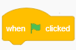from the event block

Add the ask… wait block from the sensing category

**Input**

Select radius and click make a variable- name its radius.

Add a set…. to and set radius to answer. The answer block is under the sensing block.

**Processing**

Add the set…to. Add two join blocks together. Add the variable radius in the empty spaces and add the value of pi in the third empty space.

**Output**

Add the say…for …. seconds. Insert two join blocks joined together. The first empty block holds text to be displayed “Area of a circle is”. The other block stores the result and lastly the metric (cm2)

Your code should look as the one below.

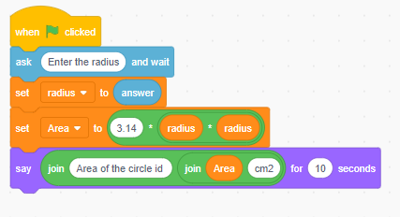

Figure 5. 13:Scratch solution for area of a square

To run the code, click the green flag  just above the stage area. The output will be displayed in the stage are next to the cat default sprite.

Now we are going to use Python to solve the same problem. We will be using Mu IDE.

**Steps**

Open Mu and save the project on to the desktop.

In our program we have a constant pi. A constant is a place in memory location whose value cannot be changed. It is helpful to think of constants as containers that hold information which cannot be changed later. We can just declare the constant and save the file with constants. Alternatively, we can declare it in our current program. For the purposes of this discussion, we are going to declare Python in the same program.

**Python**

#declaring variables and constants.

radius=int(input("Please enter the radius of the circle"))

pi=3.14

#processing

area_of_circle=pi*radius*radius

#displaying the area of the circle

print(f"The area of a circle is {area_of_circle}")

Please enter the radius of the circle5

The area of a circle is 78.5

>>>

### **5.1.20 Deploy/Run a code script (/block of code/code fragment)**

**Run/Execute the source code**

The “Run” button does exactly what you’d expect. It runs the current script. When this happens the textual **input** and **output** of the program is displayed in a panel between the text editor and Mu’s footer.

The same program can be run from the terminal. You will need to navigate to the directory where the python program is saved from the Raspberry Pi terminal. Use the cd <directoryname> to navigate to the folder. cd is short for change directory.

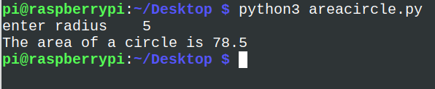

Figure 5. 14:Running Python script from the Raspberry Pi terminal

**Deploy Python Script**

After all the hard work developing a project in Python, we want to share our project with other people. It can be your friends or your colleagues. Maybe they are not interested in your code, but they want to run it and make some real use of it. There are quite a lot of platforms which you can use to deploy your Raspberry Pi scripts developed using Python such as:

* Repl.it
* Docker
* Heroku
* py2exe
* AWS

We are not going to discuss this as it is outside the scope of our syllabus. A link to deploy your project on repl.it is provided below.

**eLink**

<https://www.youtube.com/embed/WDyru4AAH-M>

### **5.1.21 Debug a code script**

An unexpected problem in your program is called a bug. Some are more difficult to fix than others, and they can take many forms. By just reading through your program, you won't be able to catch some bugs. A Python IDE such as Mu or IDLE provides some basic tools that will assist you in debugging your programs.

**Interpreter DEBUG Mode**

Turning on the built-in debugger will allow you to run your code with it. To do so, select *Debug → Debugger* from the Python IDLE menu bar. In the interpreter, you should see [DEBUG ON] appear just before the prompt (>>>), which means the interpreter is ready and waiting.

you can inspect the values of your local and global variables as your code executes. This gives your insight into how your data is being manipulated as your code runs. four checkboxes appear in the debug window, and these are:

* **Globals:** your program’s global information
* **Locals:** your program’s local information during execution
* **Stack:** the functions that run during execution
* **Source:** your file in the IDLE editor

### **5.1.22 Use various programming constructs in the development or modification of a solution**

Programs are designed using common building blocks, known as programming constructs. These programming constructs form the basis for all programs. There are three basic programming constructs, and these are:

* sequence
* selection
* iteration

Sequence is the order in which instructions occur and are processed. An example of sequence construct is the one in section 5.1.19 where instructions are executed step by step. In the program, we also made use of input command, used variables and an arithmetic calculation. The program also utilised constant pi to calculate the area of a circle whose input is captured from the keyboard.

Conditionals (Branching)

Another term used for conditionals is selection constructs. Selection determines which path a program takes when it is running. In programming, there are occasions when a decision needs to be made. Selection is the process of making a decision. The result of the decision determines which path the program will take next.

Python makes use of if statements in achieving decisions for program path.

if <expr>:

<statement>

In the form shown above:

* <expr> is an expression evaluated in a Boolean context. The outcome of the expression evaluates to either True or False.
* <statement> is a valid Python statement, which must be indented. (You will see why very soon.)

If <expr> is true, then <statement> is executed. If <expr> is false, then <statement> is skipped over and not executed.

Sometimes, you want to evaluate a condition and take one path if it is true but specify an alternative path if it is not. This is accomplished with an else clause:

Syntax

if <expr>:

<statement(s)>

elif <expr>:

<statement(s)>

elif <expr>:

<statement(s)>

...

else:

<statement(s)>

Here is an example of conditional construct implementation. The program is used for grading student marks based on the average mark supplied.

#Accepting mark

mark=int(input("Enter the average mark \t"))

#checking for condition

if (mark>89) and (mark <101):

print("You got an A grade")

elif (mark>79) and (mark <90):

print("You got an B grade")

elif (mark>59) and (mark <80):

print("You got an C grade")

elif (mark>49) and (mark <60):

print("You got an D grade")

elif (mark>39) and (mark <50):

print("You got an E grade")

elif (mark>=0) and (mark <40):

print("You got an F grade")

else:

print("Mark is outside the range")

Output

Enter the average mark 45

You got an E grade

>>>

**Iteration**

Iteration is often referred to as looping, since the program ‘loops’ back to an earlier line of code. Iteration is also known as repetition. Iteration allows programmers to simplify a program and make it more efficient. Instead of writing out the same lines of code again and again, a programmer can write a section of code once, and ask the program to execute the same line repeatedly until no longer needed. When a program needs to iterate a set number of times, this is known as definite iteration and makes use of a FOR loop.

Syntax

for i = 1 to 10

<loop body>

**Example**

Write a Python loop to print numbers 1 to 10.

for i in range(1,11):

print(i)

Output

1

2

3

4

5

6

7

8

9

10

>>>

**Post-test loops**

A post-test loop can be implemented using a do ….while loop. To create a do while loop in Python, you need to modify the while loop a bit in order to get similar behaviour to a do while loop in other languages. A do while loop will run at least once even if the condition is not met. If the condition is met, then it will run again.

Example

i =9

while True:

print(i)

i = i + 1

if(i > 5):

break

Output

9

**Pre-test loops**

This can be implemented using a while loop. The condition is checked first before executing any statements. Syntax

While test expression:

Body of while

**Example**

Write a do loop to print numbers from 0 to 10

i=0

while (i<10):

print(i)

i=i+1

Output

0

1

2

3

4

5

6

7

8

9

10

>>>

If for any reason, we initialise our i to a number greater than 10, nothing will ever be printed

**Challenge**

Write a Python program to find those numbers which are divisible by 7 and multiple of 5, between 1500 and 2700 (both included).

mylist=[]

#define the loop

for x in range(1500, 2701):

#add a condition

if (x%7==0) and (x%5==0):

#add each value meeting the condition to the list

mylist.append(str(x))

#displaying output

print (','.join(mylist))

**Activity 5.1 FORMATIVE ASSESSMENT**

**(Individual work, written and discussion activity, self-assessed).**

5.1.1 Define the term programming. (2)

5.1.2 What is meant by the term physical computing? (2)

5.1.3 List two types of signals in electronics. (2)

5.1.4 What is the difference between the two types of signals identified in question 5.3? (6)

5.1.5 What does the abbreviation GPIO stands for? (1)

5.1.6 How many pins are of the Raspberry Pi 4? (1)

5.1.7 Use Scratch to create a program which will light an LED. List the components needed and show the Scratch code. (10)

5.1.8 What do you understand by the term Integrated Development Environment. (2)

5.1.9 Write a raspberry command which can be executed from the terminal to display the GPIO pins. (1)

5.1.10 Write a Python program to convert temperatures to and from celsius, fahrenheit.    
 [ Formula : c/5 = f-32/9 [ where c = temperature in celsius and f = temperature in fahrenheit ]  
 Sample Output :  
 60°C is 140 in Fahrenheit  
 45°F is 7 in Celsius (10)

5.1.11 List THREE different constructs used in programming. (3)

**Total =[50 marks]**

## 5.2 GPIO programming, practical projects and physical computing

Content

* GPIO Programming projects
* Component input and output
* gpiozero
* Importing classes/libraries

### 5.2.1 Design simple prototypes using components connected directly to the GPIO pins

**Control LED Using Raspberry Pi GPIO**

In this project, we are going to use Scratch programming to connect an LED and configure it to blink. This is a basic project to connect an LED to RPi GPIO and control using a Scratch.

**Step 1: Components**

You will need the following components to connect the circuit.

* Raspberry Pi
* LED
* Resistor - 330 ohm
* Breadboard
* 2 Male-Female Jumper Wires

**Step 2: Connecting the Circuit**

Please keep the Raspberry Pi turned off until the circuit is connected to avoid accidentally shorting any components. The LED has 2 legs. The longer leg, 'anode', is always connected to positive supply. The shorter leg, 'cathode', is always connected to ground. You need a 330-Ohm resistor is the circuit to limit the amount of current in the circuit. Without the resistor the current flowing through the LED will be much larger and lead to a short damaging the circuit.

1. Use a jumper wire to connect the ground (Pin 3) of GPIO to rail marked in blue on the breadboard.
2. Connect the resistor from the same row on the breadboard to a column on the breadboard.
3. Connect the LED with the cathode in the same row as the resistor. Insert the anode in the adjacent row.
4. Use another jumper cable to connect the GPIO Pin 21 (3.3 V) in the same row as the anode of LED.

**Scratch Code to control the Raspberry Pi**

Start Scratch and add the Raspberry Pi GPIO extension by clicking on the bottom lower corner button on the Scratch window. Immediately you will see three Raspberry Pi blocks added.

Add a green flag from the Events block.

Add the repeat block from the control blocks. Set it to 10 seconds

Add the set gpio … to output high block. Set the gpio to 16 (Pin 36).

Add the Wait for 1 seconds block

Add the set gpio … to output high block. Set the GPIO to 16. Instead, set the output to low.

Add the Wait for 1 seconds block

Click the flag and you will see your LED blinking

Congratulations. We have set out the first project where hardware is interacting with software.

If you decide to use Python, the connection on the breadboard and GPIO remains the same.

The code on the Mu editor would be as follows.

#importing the gpiozero and time library

from gpiozero import LED

from time import sleep

green = LED(16)

#Turning On/Off the LED using

green.on()

sleep(1)

green.off()

sleep(1)

When you run the above code, the light will only turn on once and switch off. This is simply because the code is sequential execution. We will discuss about repetition later in this module.

### 5.2.2 Incorporate the use of input components and control output components using a single board computer

Now we want to accept input from the Raspberry Pi and let the Pi to respond accordingly.

**Challenge**

We are going to modify the grading program in section 5.1.22 to include physical computing. In this exercise, we want to do the following:

Turn the green LED light on as long as the student got a B grade or higher, turn the orange light when a student gets a C or D grade, turn red if the pass mark is between 0 and 49 otherwise turn all three lights on if the mark is outside the range.

You will need:

* A breadboard
* 3 LEDs (red, green and orange)
* 6 female-to-male jumper cables
* 3x 330 Ohm resistors

Connect the cathode to the following pins on the Raspberry Pi.

* Green to pin (22)
* Orange to pin (27)
* Red to pin (17)

The Python Program will look as below:

from gpiozero import LED

from time import sleep

green=LED(22)

orange=LED(27)

red=LED(17)

try:

#Accepting mark

mark=int(input("Enter the average mark \t"))

#checking for condition

if (mark>89) and (mark <101):

green.on()

print("You got an A grade")

sleep(5)

green.off()

elif (mark>79) and (mark <90):

green.on()

print("You got an B grade")

sleep(5)

green.off()

elif (mark>59) and (mark <80):

orange.on()

print("You got an C grade")

sleep(5)

orange.off()

elif (mark>49) and (mark <60):

orange.on()

print("You got an D grade")

sleep(5)

orange.off()

elif (mark>39) and (mark <50):

red.on()

print("You got an E grade")

sleep(5)

orange.off()

elif (mark>=0) and (mark <40):

red.on()

print("You got an F grade")

sleep(5)

red.off()

else:

red.on()

green.on()

orange.on()

print("Mark is outside the range")

sleep(5)

red.off()

green.off()

orange.off()

### 5.2.3 Incorporate and use different polarized components as part of the design

**Raspberry Pi: Control Relay switch via GPIO**

Often you want to control modules with a higher voltage with the Raspberry Pi. For this purpose, relays can be used on the Raspberry Pi: The relay “switch” is utilized by means of a low-voltage pulse. Since the Pi only tolerates a maximum of 5V (the GPIOs even only 3.3V) without relays, there is the risk that the Pi could burn out. However, if you have two separate circuits this cannot happen.

**Required Hardware Parts**

* [5V relay module](https://www.amazon.com/s/ref=nb_sb_ss_c_1_15?url=search-alias%3Daps&field-keywords=5v+relay+module&sprefix=5V+relay+module%2Caps%2C260&crid=3PUBGVCUJT6NV&tag=754u-20)*
* Female – Female [jumper cable](https://www.amazon.com/s/ref=nb_sb_ss_c_1_28?url=search-alias%3Daps&field-keywords=female+jumper+cable&sprefix=Female+-+Female+jumper+cable%2Caps%2C721&crid=36Q8YEMZICR4A&rh=i%3Aaps%2Ck%3Afemale+jumper+cable&tag=754u-20)*
* an external circuit (e.g., [batteries](https://www.amazon.com/s/ref=nb_sb_noss_2?url=search-alias%3Daps&field-keywords=bateries&rh=i%3Aaps%2Ck%3Abateries&tag=754u-20)*) and an application (eg, motors)

**Connections**

(GND) comes to pin 6 of the Pi (GND), the right pin (VCC) comes to 3V3 (pin 1) of the Pis. Depending on how many of the relays you want to control, you need to connect a corresponding number of GPIOs to the IN pins. It is recommended to set a small resistor between the Pi and the relay. If you set 5V instead of 3.3V to VCC, you should definitely put one resistor each (~ 1kΩ) between the GPIOs and the IN pins.

Code

import RPi.GPIO as GPIO

GPIO.setmode(GPIO.BCM) # GPIO Numbers instead of board numbers

RELAIS_1_GPIO = 17

GPIO.setup(RELAIS_1_GPIO, GPIO.OUT) # GPIO Assign mode

GPIO.output(RELAIS_1_GPIO, GPIO.LOW) # out

if you want the relay to open at a HIGH level, you need to connect the middle and left pins to the circuit. The LED is off there. If the relay is to open, if the LED is also on, middle and right-OUT pins are connected.

### 5.2.4 Build simple prototypes using components connected directly to the GPIO pins

When you first start using these GPIO pins, it’s wise to use a breadboard. This makes it easy to build circuits without solder and to modify them. It is safe to connect a GPIO set as an INPUT to any voltage between 0 to 3V3 volts. It is safe to connect a GPIO set as an INPUT to a GPIO set as an OUTPUT. There is a risk in connecting two GPIO both set as OUTPUTs. One may be set to 0V and the other to 3V3 which is in effect a short circuit.

To mitigate the risk of setting two GPIO as OUTPUTs to a different level it is prudent to always have something like a 300-ohm resistor in series whenever you connect one GPIO to another GPIO. Having a resistor in series between GPIO will never do any harm.

### 5.2.5 Read data from analogue and digital inputs and control analogue and digital outputs

**Generic motor connected to a bi-directional motor driver circuit**

Attach an [H-bridge](https://en.wikipedia.org/wiki/H_bridge) motor controller to your Pi; connect a power source (e.g. a battery pack or the 5V pin) to the controller; connect the outputs of the controller board to the two terminals of the motor; connect the inputs of the controller board to two GPIO pins.

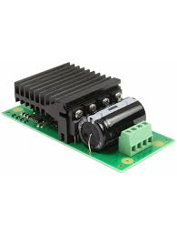

Figure 5. 15: H-Bridge Motor Driver

The following code will make the motor turn “forwards”:

**from** **gpiozero** **import** Motor

motor = Motor(17, 18)

motor.forward()

Run the code above and you will see the motor rotating.

### 5.2.6 Use basic programming constructs to create simple programs

GPIO Zero is a zero-boilerplate Python library that makes [physical computing with Python](https://projects.raspberrypi.org/en/projects/physical-computing) more accessible and helps people progress from *zero* to *hero*. We have done examples of switching a LED light using Raspberry Pi. We imported gpiozero and we used the GPIO pins not the normal pin numbers. You can revisit any of the projects we have done so far, and you will notice that we used gpiozero to interface with our physical computing components.

### 5.2.7 Initiate and setup Python program that imports gpiozero

### 5.2.8 Write Python code to support reading from and control digital and analogue inputs using

### 5.2.8.1 pause from the signal module

A signal can be stopped by turning it off. Cause the process to sleep until a signal is received; the appropriate handler will then be called. pause() acts as an interrupt to the existing flow.

### 5.2.8.2 sleep from the time module

The random module code implements the sleep from the time module. The time module in Python allows programs to count time, sleep or pause a number of seconds or minutes as defined by the user. This module provides various time-related functions. For related functionality, see also the [datetime](https://docs.python.org/2/library/datetime.html#module-datetime) and [calendar](https://docs.python.org/2/library/calendar.html#module-calendar) modules. Here is an example of time implementation.

import time

start = time.time()

time.sleep(4)

end = time.time()

duration = end - start

print("I slept for {} seconds".format(duration))

### 5.2.8.3 The random module

**Using the random library**

We are going to randomize which light is turned on, and how long the program will wait before turning the next light on. To generate random numbers, you need to use Python’s random library.

The Explorer HAT has touch buttons labelled from 1 to 4, and four LED lights in different colours. The aim of the game is to program the Explorer HAT to turn a light on at random, at which point the player must press the corresponding button to turn the light off. If the player is too slow, or if they press the wrong button, the game is over.

Setting up

* Carefully mount the Explorer HAT onto the GPIO pins on your Raspberry Pi, then boot the Pi.

Code

from time import sleep

from gpiozero import LED

import explorerhat

import random

light = random.randint(1,4)

if light == 1:

explorerhat.light.blue.on()

sleep(2)

explorerhat.light.blue.off()

elif light == 2:

explorerhat.light.yellow.on()

sleep(2)

explorerhat.light.yellow.off()

elif light==3:

explorerhat.light.red.on()

sleep(2)

explorerhat.light.red.off()

else:

print("Error connecting")

**eLink**

<https://projects.raspberrypi.org/en/projects/lights-out/5>

### 5.2.8.4 Selection structures

By now you are familiar with using LED lights on a raspberry pi. We want to turn the light on when specific values for body temperature are supplied by the user. If the value entered is equal to 39, print ‘Too high’, 34 , print warning, 37.5 print ‘OK’ else print abnormal temperature.

Code

import RPi.GPIO as GPIO

import time

GPIO.setmode(GPIO.BOARD)

GPIO.setup(12,GPIO.OUT)

GPIO.setup(16,GPIO.OUT)

# reset the LEDs to off!

GPIO.output(12,GPIO.LOW)

GPIO.output(16,GPIO.LOW)

variable1=float(input(“Enter value of variable 1”)

if variable1==39:

print 'Too high'

elif variable1==34:

print 'warning'

GPIO.output(12,GPIO.HIGH)

time.sleep(3)

elif variable1==37:

print 'OK'

GPIO.output(16,GPIO.HIGH)

time.sleep(3)

else:

print 'Abnormal temperature'

GPIO.cleanup()

### 5.2.8.5 Repetition structures

So let us implement loops with physical computing. We want to turn an LED using a while loop.

Connect the LED and resistor on to the breadboard. Use pin 18 (GPIO 24) for the positive connection. The anode can be connected to any ground pin on the raspberry pi. Import 2 libraries: gpiozero and LED to allow accessing the gpio pins and LED for the lights.

Here is the code

from gpiozero import LED

from time import sleep

led=LED(24)

while True:

led.on()

sleep(2)

led.off()

sleep(5)

gpiozero.cleanup()

Please take note on the above code, we implemented the cleanup( ) method so that whenever you press control +c on the keyboard an interrupt is activated and stops the LED.

**Challenge**

Use a for loop to allow the LED to blink five times only.

Solution

from gpiozero import LED

from time import sleep

led=LED(24)

for x in range(0,5):

led.on()

sleep(2)

led.off()

sleep(2)

gpiozero.cleanup()

### 5.2.9 Python code to read from / control digital and analogue inputs using gpiozero classes

### 5.2.9.1 LED

LEDs are delicate little things. If you put too much current through them, they will pop (sometimes quite spectacularly). To limit the current going through the LED, you should always use a resistor in series with it. Section 5.2.1 outlined how you can connect an LED light to the Raspberry Pi and turn the LED on and off.

### 5.2.9.2 Button

As well as controlling the physical world, you can react to it using an input device such as a button. Connect your button to a breadboard, and then connect one pin to a ground pin and the other to a numbered GPIO pin. In this example pin 2 has been used.

* Create a new file by clicking New.
* Save the new file by clicking Save. Save the file as gpio_button.py.
* This time you’ll need the Button class, and to tell it that the button is on pin 2. Write the following code in your new file:

The connection should look as shown on the diagram below.

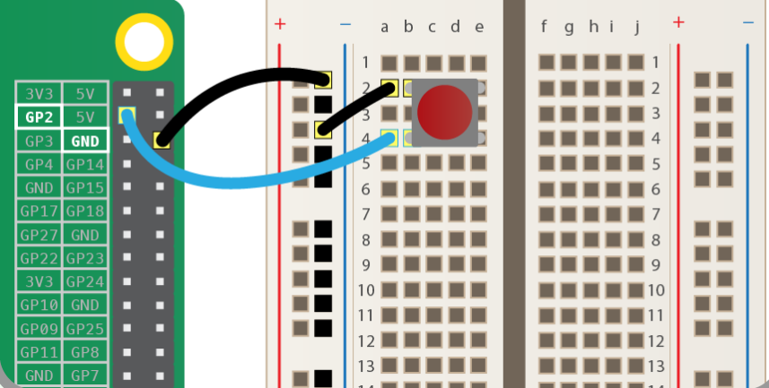

Figure 5. 16: Button

**Python code**

from gpiozero import Button

button = Button(2)

button.wait_for_press()

print('You pressed the button”)

Output

You pressed the button

### 5.2.9.3 RGBLED

An RGB LED contains four pins: one for each colour (Red, Green, and Blue) and one for the common cathode. It features three separate colour-emitting diodes that may be combined to produce a wide range of colours! Depending on how light each diode is, any colour is possible. This guide will teach you how to utilize an RGB LED with a Raspberry Pi to generate unique colour combinations.

Step 1: What You Will Need

For this tutorial you will need:

* [GPIO Breakout(optional)](https://grobotronics.com/t-cobbler-plus-gpio-breakout-for-raspberry-pi-3-2-b.html)
* [Breadboard](https://grobotronics.com/breadboard-1360-tie-point-medium.html)
* [RGB LED](https://grobotronics.com/led-clear-5mm-rgb-common-anode.html)
* [3x220 Ohm resistors](https://grobotronics.com/resistor-1-2w-carbon-5-220ohm.html)
* Stripline pin or [some jumper cables](http://amzn.to/2ekI7r3) for Raspberry Pi

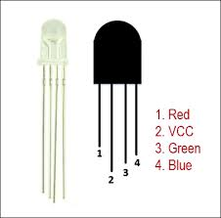

Figure 5. 17: RGBLED

**Connections**

Plug the circuit on GPiO in this position. We connected the VCC (Cathode) to pin number 1 on the breadboard.

Red Pin number 32 (GPIO12)

Green -Pin number 33 (GPIO13)

Blue – Pin number 35 (GPIO19)

Each of the three pins (RGB) have a resistor on the breadboard as shown on the diagram.

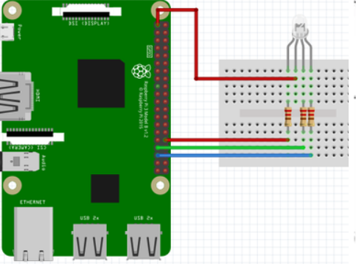

Figure 5. 18: RGBLED connection

Pay attention of the numbers of pin. In this project we use a GPIO pin number. Please double-check before starting your system. You can burn Raspberry Pi.

The combination of the three colours is made to produce one colour and they are each either set to low or high. For example, to produce the white colour, the GPIO pins are set to output mode and the following combinations are applied:

* GPIO.output(redPin,GPIO.LOW)
* GPIO.output(greenPin,GPIO.LOW)
* GPIO.output(bluePin,GPIO.LOW)

Run the program and you will notice different colours (more than 3 colours). RGB LEDs contain a Red, Green and Blue LED. You can mix any colour by using the correct scale of the 3 basic colours. If you grow brightness and keep scale at the same time, you can show the same colour even brighter. The brightness of basic colours can be set from 0 to 255.

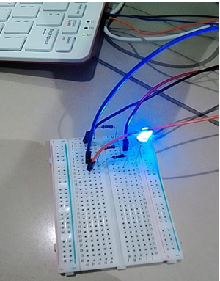

Figure 5. 19: RGBLED

**Solution in Python**

#libraries

import RPi.GPIO as GPIO

from time import sleep

#disable warnings (optional)

GPIO.setwarnings(False)

#Select GPIO Mode

GPIO.setmode(GPIO.BCM)

#set red,green and blue pins

redPin = 12

greenPin = 19

bluePin = 13

#set pins as outputs

GPIO.setup(redPin,GPIO.OUT)

GPIO.setup(greenPin,GPIO.OUT)

GPIO.setup(bluePin,GPIO.OUT)

def turnOff():

GPIO.output(redPin,GPIO.HIGH)

GPIO.output(greenPin,GPIO.HIGH)

GPIO.output(bluePin,GPIO.HIGH)

def white():

GPIO.output(redPin,GPIO.LOW)

GPIO.output(greenPin,GPIO.LOW)

GPIO.output(bluePin,GPIO.LOW)

def red():

GPIO.output(redPin,GPIO.LOW)

GPIO.output(greenPin,GPIO.HIGH)

GPIO.output(bluePin,GPIO.HIGH)

def green():

GPIO.output(redPin,GPIO.HIGH)

GPIO.output(greenPin,GPIO.LOW)

GPIO.output(bluePin,GPIO.HIGH)

def blue():

GPIO.output(redPin,GPIO.HIGH)

GPIO.output(greenPin,GPIO.HIGH)

GPIO.output(bluePin,GPIO.LOW)

def yellow():

GPIO.output(redPin,GPIO.LOW)

GPIO.output(greenPin,GPIO.LOW)

GPIO.output(bluePin,GPIO.HIGH)

def purple():

GPIO.output(redPin,GPIO.LOW)

GPIO.output(greenPin,GPIO.HIGH)

GPIO.output(bluePin,GPIO.LOW)

def lightBlue():

GPIO.output(redPin,GPIO.HIGH)

GPIO.output(greenPin,GPIO.LOW)

GPIO.output(bluePin,GPIO.LOW)

while True:

turnOff()

sleep(1) #1second

white()

sleep(1)

red()

sleep(1)

green()

sleep(1)

blue()

sleep(1)

yellow()

sleep(1)

purple()

sleep(1)

lightBlue()

sleep(1)

**MotionSensor**

In this circuit, you will be connecting a **passive infrared (PIR) motion sensor** to the Raspberry Pi. A passive infrared motion sensor detects any motion in its field of vision and sends a signal back to the Raspberry Pi. The motion sensor consists of three pins:

1. VCC for voltage
2. OUT for communicating with the Raspberry Pi
3. GND for ground

**Adjusting the Sensor**

When using a motion sensor, you may need to adjust how sensitive it is to motion and how long it will send out a signal after motion is detected. You can make adjustments using two dials on the side of the sensor. See the image of the motion sensor shown below.

**Connecting the Motion Sensor**

We are also going to allow an LED light to turn on if a motion has been detected and turn off if no motion has been detected. So, we will stick to the earlier connection for our LED.

Using these pins, you need to take the following steps:

1. Connect a female-to-female jumper wire from the Raspberry Pi’s 5V pin to the sensor’s VCC pin. (Pin 2)
2. Connect a female-to-female jumper wire from the Raspberry Pi’s GPIO4 pin (Pin 7) to the sensor’s OUT pin.
3. Connect a female-to-female jumper wire from the Raspberry Pi’s GND pin to the sensor’s GND pin.(Pin 6)

Our connection for the sensor and the GPIO header will be as shown on the figure below.

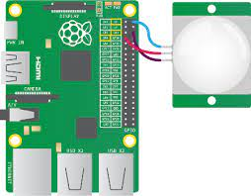

Figure 5. 20:Motion Sensors

With the motion sensor adjusted and wired to the Raspberry PI, let us look at the Python code for detecting motion.

from gpiozero import LED

from time import sleep

from gpiozero import MotionSensor

pir=MotionSensor(4)

green=LED(16)

green.off()

while True:

pir.wait_for_motion()

print(Motion detected”)

green.on()

pir.wait_for_no_motion()

green.off()

print(“Motion stopped”)

**NOTE**

Make sure to move the sensor as far from the Raspberry Pi as possible to avoid occasional false positives.

### 5.2.9.2 Buzzer

There are two main types of buzzers: active and passive. A passive buzzer emits a tone when a voltage is applied across it. It also requires a specific signal to generate a variety of tones. In this module, we will cover an active buzzer. An *active* buzzer can be connected just like an LED, but as they are a little more robust, you won’t be needing a resistor to protect them.

The diagram below illustrates the simple connection you will need to do for an active buzzer.

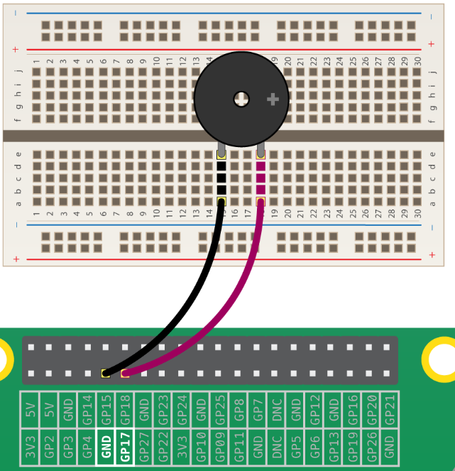

Figure 5. 21: Connecting a buzzer

**Python Code**

from gpiozero import Buzzer

from time import sleep

buzzer=Buzzer(17)

while True:

buzzer.on()

sleep(1)

buzzer.off()

sleep(1)

When the program is run, the buzzer begins to buzz: one second on, and one second off. If we had used a passive buzzer, you would hear a brief click every second instead of a continuous buzz.

### 5.2.9.3 LightSensor

A light sensor is a kind of photodiode. These components convert light into energy. The output from a photodiode can be measured and used to trigger specific functions.

In basic terms, these are diodes that detect light and give an output based on the level of light they receive. We can use the output in custom programs and projects. Light sensors can be used to trigger night lights or even help you monitor the light levels within a given space.

We are going to calculate how long it takes to charge a capacitor in a circuit containing a variable resistance resistor. The resistor being used is a photoresistor, so depending on how much light is present, the resistance changes. When light is present, the resistance is lower, making it faster to charge the capacitor. When light is not present, the resistance is higher, making it slower to charge the capacitor. We use the Raspberry Pi to constantly read voltage values to determine how long it takes to charge the capacitor. Since the Pi does not have any analog pins, we cannot read the resistance from the photoresistor directly without an Analog-to-Digital converter.

**What you need**

* Photoresistors
* Breadboards
* Breadboard Jumper Wires
* Capacitors
* Red Dot Laser Head/Diode

Here is the diagram which shows the connection which we are emulating

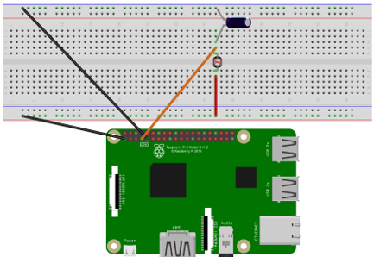

Figure 5. 22: LightSensor

**Connections**

* Connect the capacitor to the resistor through the breadboard. The positive leg of the positive leg of the capacitor to the photo
* Connect the negative leg of the capacitor to ground
* connect the 3.3-volt pin as well as the ground pin on the Raspberry Pi to the breadboard
* the positive leg of the capacitor connects to one of the PI's GPIO pins using a jumper
* the leg of the photo resistor wire
* connect the other leg of the photo resistor to power with another jumper wire

**Python Code**

import RPi.GPIO as GPIO

import time

GPIO.setmode(GPIO.BOARD)

resistorPin = 7

while True:

GPIO.setup(resistorPin, GPIO.OUT)

GPIO.output(resistorPin, GPIO.LOW)

time.sleep(0.1)

GPIO.setup(resistorPin, GPIO.IN)

currentTime = time.time()

diff = 0

while(GPIO.input(resistorPin) == GPIO.LOW):

diff = time.time() - currentTime

print(diff * 1000)

time.sleep(1)

**Run the program**

Our program will show the difference in time it takes the capacitor to charge between when the light intensity is high and when the light intensity is low by using the laser diode.

### 5.2.9.4 MCP3008 (Analogue to digital converter)

**Analogue inputs**

The Raspberry Pi’s GPIO pins are digital pins, so you can only set outputs to high or low, or read inputs as high or low. However, using an ADC chip (Analogue-to-Digital converter), you can read the value of analogue input devices such as potentiometers.

**Wiring the ADC (MCP3008)**

The MCP3008 is an ADC providing eight input channels. The eight connectors on one side are connected to the Pi’s GPIO pins, and the other eight are available to connect analogue input devices to read their values.

Place the MCP3008 chip on a breadboard and carefully wire it up as shown in the following diagram.

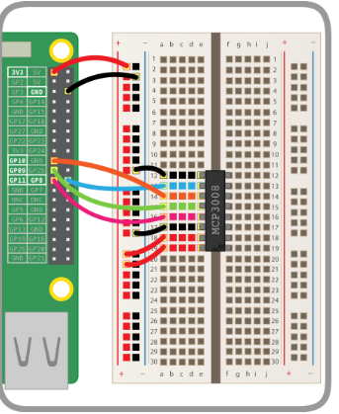

Figure 5. 23: Analog-to-Digital Convertor

**Add a potentiometer**

Now that the ADC is connected to the Pi, you can wire devices up to the input channels. A potentiometer is a good example of an analogue input device: it’s simply a variable resistor, and the Pi reads the voltage (from 0V to 3.3V).

A potentiometer’s pins are ground, data, and 3V3. This means you connect it to ground and a supply of 3V3 and read the actual voltage from the middle pin.

### Source and values

GPIO Zero has a powerful feature: source and values. Every device has a value property (the current value). Every output device has a source property which can be used to set what the device’s value should be.

* pot.value gives the potentiometer’s current value (it’s read only, as it’s an input device)
* led.value is the LED’s current value (it’s read/write you can see what it is, and you can change it)

Code

from gpiozero import PWMLED

led = PWMLED(21)

led.on() # the led should be lit

led.off() # the led should go off

led.value = 0.5 # the led should be lit at half brightness

while True:

led.value = pot.value

### LEDBarGraph

LED bar graphs consist of several LEDs embedded into a single component. In the picture below the bar graph contains 10 LEDs arranged side-by-side. LED bar graphs have several uses including:

* Progress indicators
* Battery charge
* Voltmeter
* Sound meter
* Speed

There are many other applications of LED bar graphs.

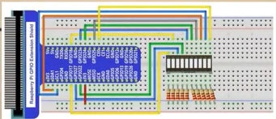

Figure 5. 24:LEDBarGraph

Items needed

* 11 Jumper cables
* Breadboard
* Led Bargraph segment
* Connections

We are going to connect the 10 jumper cables of the anode all in one column next to the led graph segment

Connect the resistors on the other side of the segment. Connect a jumper cable too the 3.3v pin on the breadboard

NB: This time we used the normal board numbers instead of the gpiozero

Code

import RPi.GPIO as GPIO

import time

ledPins = [11,12,13,15,16,18,22,3,5,24]

def setup():

print("Program is starting")

GPIO.setmode(GPIO.BOARD)

for led in ledPins:

GPIO.setwarnings(False)

GPIO.setup(led, GPIO.OUT)

GPIO.output(led, GPIO.HIGH)

def loop1():

while True:

for led in ledPins:

GPIO.output(led, GPIO.LOW)

time.sleep(0.1)

GPIO.output(led, GPIO.HIGH)

for led in ledPins[10:0:-1]:

GPIO.output(led, GPIO.LOW)

time.sleep(0.1)

GPIO.output(led, GPIO.HIGH)

def destroy():

for led in ledPins:

GPIO.output(led, GPIO.HIGH)

GPIO.cleanup()

if __name__=='__main__':

setup()

try:

loop1()

except KeyboardInterrupt:

destroy()

Run your code and you will see each segment of the ledgraph lighting.

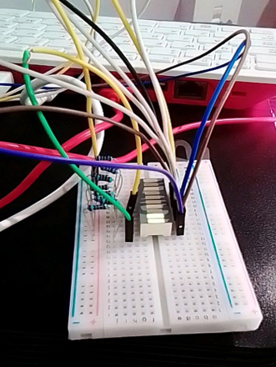

Figure 5. 25:LedBarGraph Output

**Chapter Summary**

This chapter has introduced programming using Scratch and Python. We then moved on to link physical computing using the Raspberry Pi and the named programming languages. Several projects highlight the extent to which programming is used in our day-to-day lives. We believe by now you understand the importance of this module and that it gives you a solid platform upon which you can build your own projects.

**Activity 5.2 FORMATIVE ASSESSMENT**

**(Individual work, written and discussion activity, self-assessed).**

5.2.1 Write a Python code to control an LED with push button. (20)

**Total =[20 marks]**

**Activity 5.3 SUMMATIVE ASSESSMENT**

**(Individual work, written and discussion activity, self-assessed).**

5.3.1 List any FOUR factors that can be used to evaluate programming code. (4)

5.3.2 There is a continuous representation of signals in analog signals. True or False. (1)

5.3.3 What is the use of GPIO pins on the Raspberry Pi? (2)

5.3.4 What will be the output of the following statement on Python Shell and give a reason. (2) eval("6+6")

5.3.5 Differentiate the terms input and output as applied to the Raspberry Pi. (4)

5.3.6 What do you understand by deploying an application? (2)

5.3.7 Write a Python Code on the Raspberry Pi to read the temperature using DS18B20 Temperature Sensor. (20)

**Total= [35 marks]**

References

Lobontiu, N., 2017. System dynamics for engineering students: Concepts and applications.